**CERTIFICATE OF ATTENDANCE** 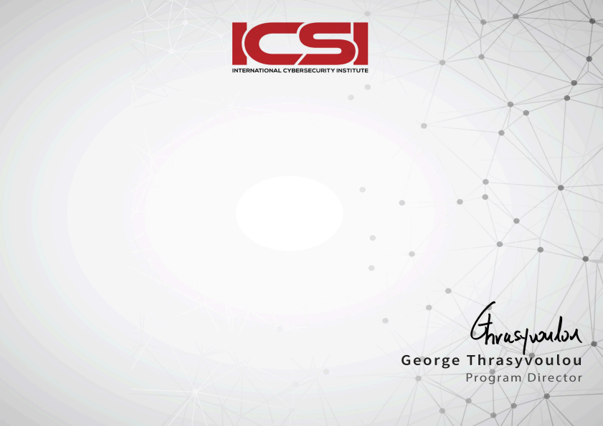

**Ahmed Abdu**

*has successfully completed the course*

**ICSI | CNSS Certified Network**

**Security Specialist**

May 27, 2020

Credential Number: 18680713